different dropdowns present in the function library. For example

AutoSum, Recently Used, Text, Date & Time, etc.

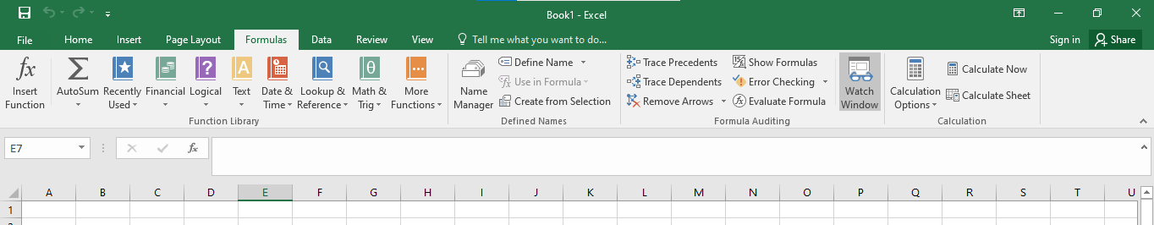

**2. What are the different ways you can select columns and rows?**

Drag and click

Hold shift and click till you want to select

Ctrl+ Shift+ up and down arrow

Drag or select ROW 1234 OR COLUMN ABCD ECT

**3. What is AutoFit and why do we use it?**

AutoFit is **a feature in Excel that lets you easily change the size of one or multiple columns or rows on a spreadsheet**. It helps you make sure that all the data in every cell group is clearly visible.

Select table and

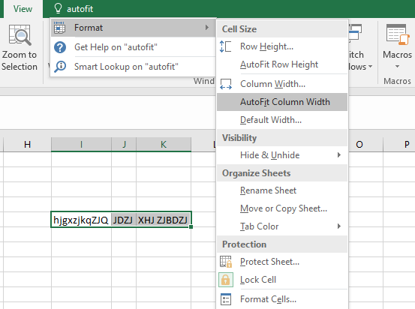

**4. How can you insert new rows and columns into the existing table?**

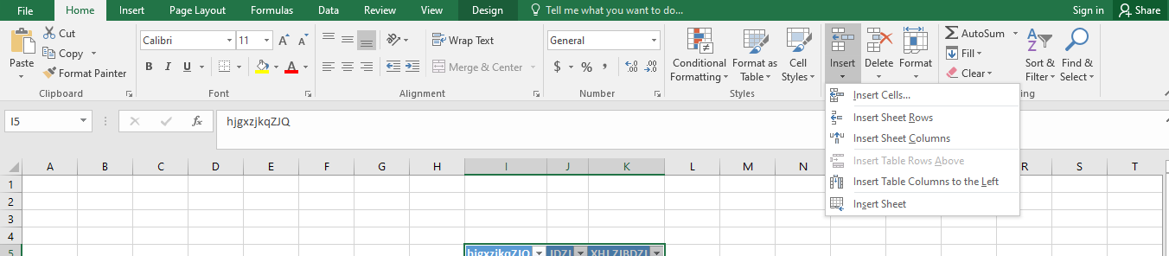

**5. How do you hide and unhide columns in excel?**

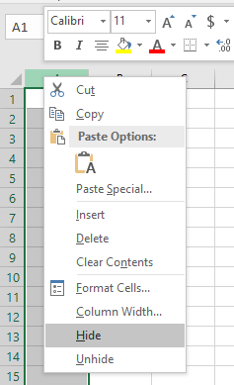

**6. Create an appropriate table within the worksheet and use different**

**functions available in the AutoSum command.**

